1.

C Program:
1 #include <stdio.h>
2 #include <string.h>
3
4 void main(int argc,char *argv[]){
5 FILE *fp1,*fp2;
6 if(argc!=3){
7 printf("Incorrect File Names Given\n");
8 }
9 else{
10 int i=0;
11 char f1[40],f2[40];
12 strcpy(f1,argv[1]);
13 strcpy(f2,argv[2]);
14 fp1=fopen(f1,"r");
15 fp2=fopen(f2,"r");
16 if(fp1 == NULL){
17 printf("File Does not Exist");
18 }
19 else{
20 if(fp2!=NULL){
21 int choice;
22 printf("This File Exists, 1. Overwrite, 2.Append \n");
23 scanf("%d",&choice);
24
25 if(choice == 2){
26 fclose(fp2);
27 fp2 = fopen(f2,"a");
28 }
29 else{
30 fclose(fp2);
31 fp2 = fopen(f2,"w");
32 }
33 }
34 else{
35
36 fp2 = fopen(f2,"w");
37 }
38 while (1){
39 char a;
40 a = fgetc(fp1);
41 if (a==EOF){
42 break;
43
44 }
45 else{
46 putc(a,fp2);
47 }
48
49 }
50 fclose(fp1);
51 fclose(fp2);
52 }
53 }
54 }

;Input/Output:

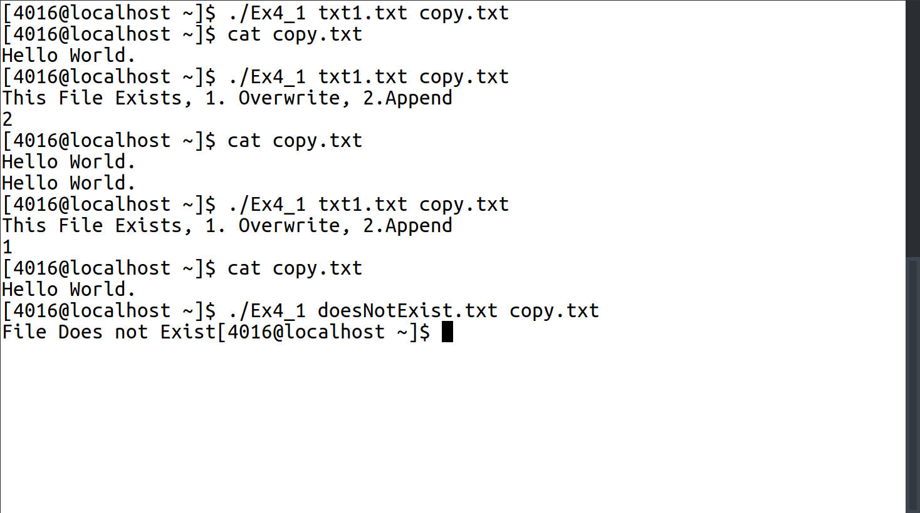

2.

C Program:
1 #include <stdio.h>
2 #include <stdarg.h>
3 #include <stdlib.h>
4 #include <string.h>
5
6
7 void main(int argc, char const *argv[]){
8 FILE *f1;
9
10 int n,i;
11 f1 = fopen("phonebook.txt","a+");
12 if(argc>1){
13 n = atoi(argv[1]);
14
15 for(i=0;i<n;i++){
16 char name[80];
17 int no;
18 printf("Enter Name\n");
19 scanf("%s",name);
20 printf("Enter Number\n");
21 scanf("%d%*c",&no);
22 fprintf(f1, "%d %s\n",no,name);
23 }
24 }
25 char query[80];
26 char line[400];
27 int flag = 0;
28 printf("Enter Name to Search for\n");
29 scanf("%s",query);
30 rewind(f1);
31 while(!feof(f1)){
32 fgets(line,400,f1);
33 //printf("%s\n",line );
34 if(strstr(line,query)){
35 printf("Phone Number Found : %s\n",line );
36 flag = 1;
37 }
38
39 }
40 if(flag == 0){
41 printf("Not Found\n");
42 }
43 fclose(f1);
44 }

Input/Output:

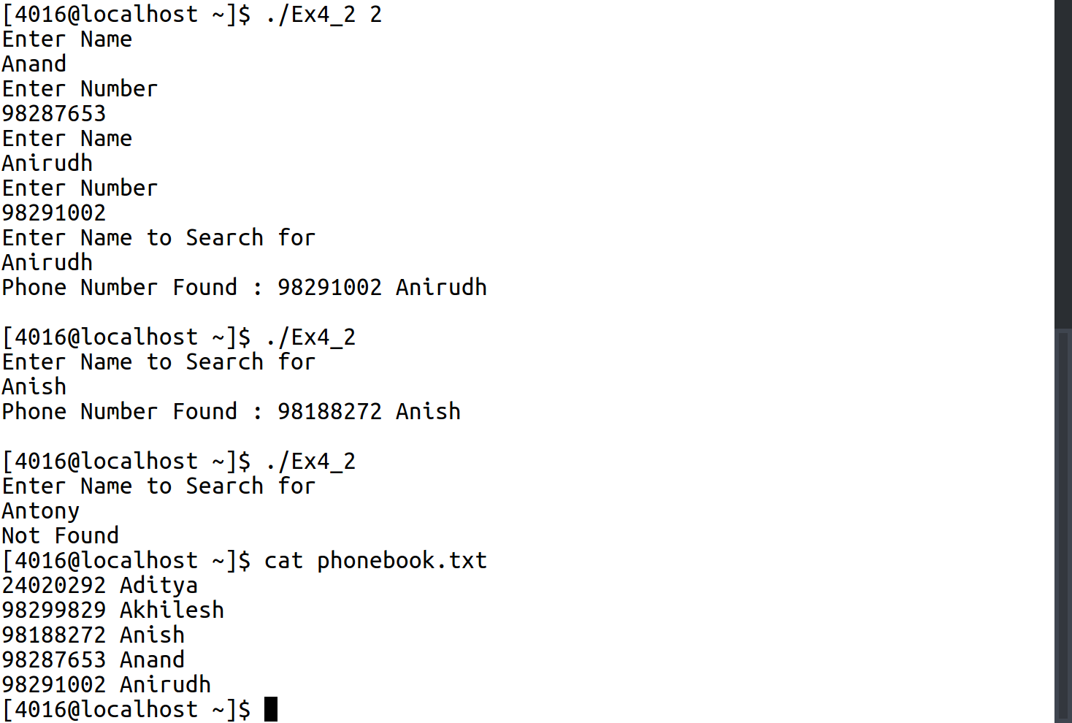

3.

C Program:
1 #include<stdio.h>
2 typedef struct
3 {
4 long stud_id;
5 char name[40];
6 int stud_dob[3];
7 float stud_cpga;
8
9 }student;
10 void append()
11 {
12 FILE *f1;
13 f1=fopen("STUDENT.txt","a");
14 student a[1];
15 printf("Enter the ID_no: ");
16 scanf("%ld",&a[0].stud_id);
17 printf("Enter the name: ");
18 scanf("%s",a[0].name);
19 printf("Enter the DOB in the format dd/mm/yyyy: ");
20 scanf("%d/%d/%d",&a[0].stud_dob[0],&a[0].stud_dob[1],&a[0].stud_dob[2]);
21 printf("Enter the student CGPA: ");
22 scanf("%f",&a[0].stud_cpga);
23 fwrite(a,sizeof(a),1,f1);
24 fclose(f1);
25 }
26
27 void display()
28 {
29 FILE *f1;
30 f1=fopen("STUDENT.txt","r");
31 student a[1];
32 while(fread(a,sizeof(a),1,f1))
33 {
34 printf("The Stud_Id: %ld\n",a[0].stud_id);
35 printf("Student Name: %s\n",a[0].name);
36 printf("Student DOB: %d/%d/%d\n",a[0].stud_dob[0],a[0].stud_dob[1],a[0].stud_dob[2]);
37 printf("Student CGPA: %.2f\n",a[0].stud_cpga);
38 }
39 fclose(f1);
40 }
41 void display_size()
42 {
43 FILE *f1;
44 f1=fopen("STUDENT.txt","r");
45 fseek(f1,0,2);
46 int size = ftell(f1);
47 printf("%d\n",size);
48 fclose(f1);
49 }
50 void display_m()
51 {
52 FILE * f1;
53 f1=fopen("STUDENT.txt","r");
54 student a[1];
55 int m;
56 printf("Enter the record no:");
57 scanf("%d",&m);
58 fseek(f1,m*sizeof(a),0);
59 fread(a,sizeof(a),1,f1);
60 if(feof(f1))
61 {
62 printf("NOT FOUND\n");
63 return ;
64 }
65 printf("The Stud_Id: %ld\n",a[0].stud_id);
66 printf("Student Name: %s\n",a[0].name);
67 printf("Student DOB: %d/%d/%d\n",a[0].stud_dob[0],a[0].stud_dob[1],a[0].stud_dob[2]);
68 printf("Student CGPA: %f\n",a[0].stud_cpga);
69 fclose(f1);
70 }
71 int main()
72 {
73 void (*ptr[4])()={append,display,display_size,display_m};
74 int choice;
75 printf("1.Append \n2.Display \n3.Display size \n4.Display mth\nEnter your choice:");
76 scanf("%d",&choice);
77 while(choice>0&&choice<5)
78 {
79 (*ptr[choice-1])();
80 printf("1.Append \n2.Display \n3.Display size \n4.Display mth\nEnter your choice:");
81 scanf("%d",&choice);
82 }
83 }

Input/Output:
